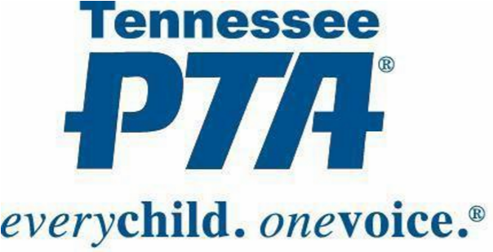 **LOCAL UNIT BYLAWS** **SUBMITTAL COVER SHEET**

1905 Acklen Avenue Nashville, TN 37212

(615) 383- 9740

Fax (615) 383-9741

**Submittal Process:**

Include **two (2)** copies of this form and **two (2)** copies of bylaws

Complete **ALL** required information

Mail to Tennessee PTA office

Online submittal is allowed, provided that this cover sheet is faxed to office

**All Local Unit information MUST be completed.**

**FOR COMPLETION BY LOCAL UNIT**

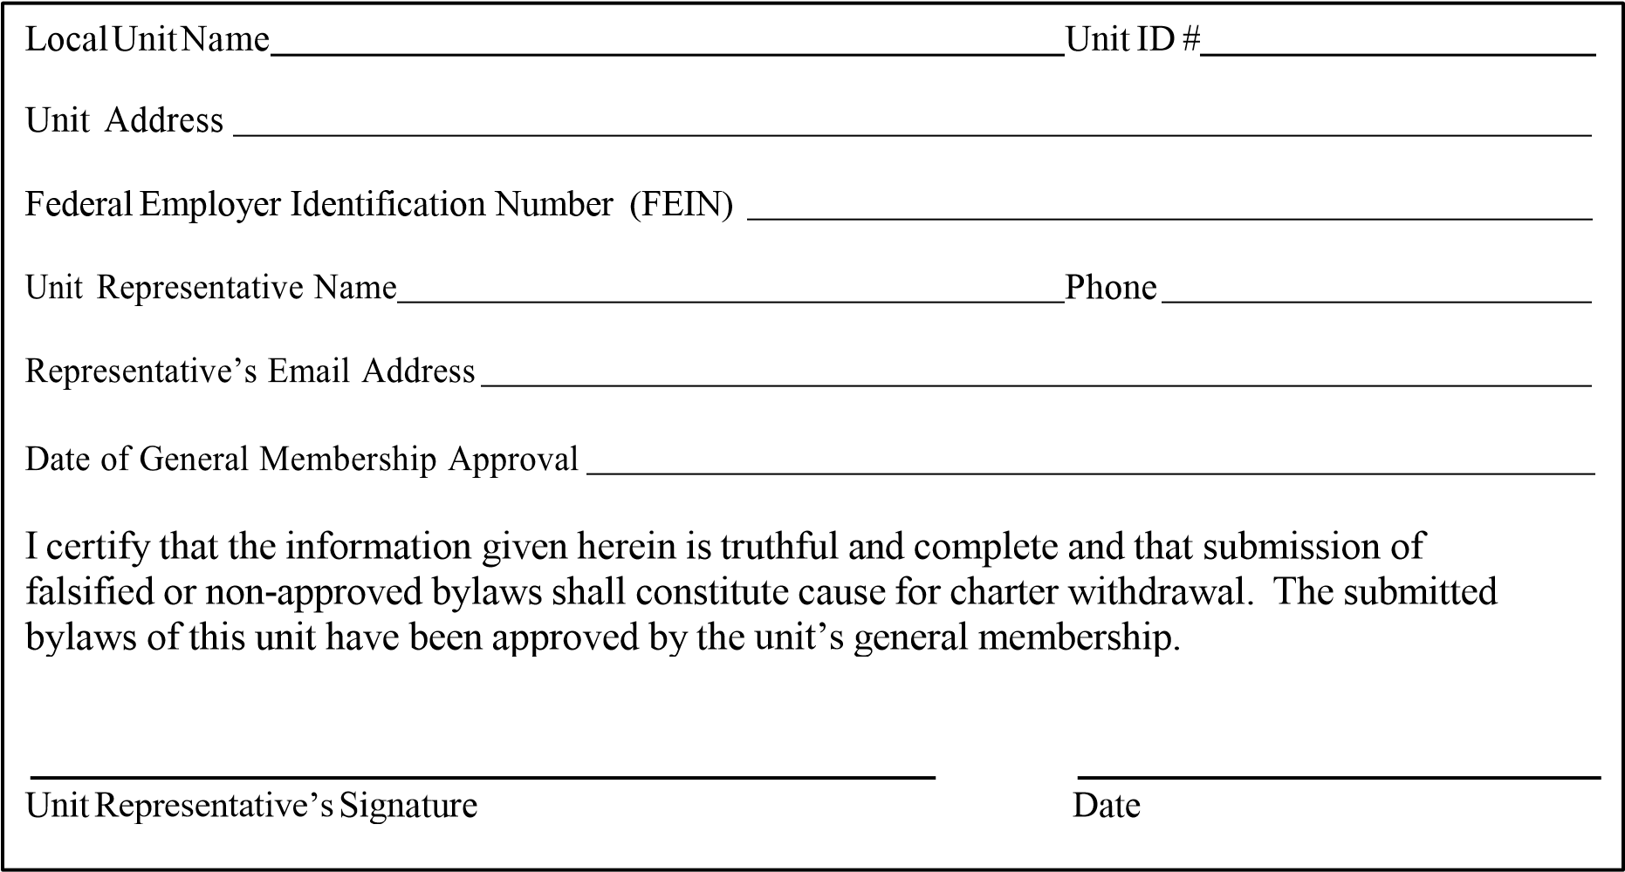

**FOR TENNESSEE PTA USE ONLY**

|  |
| --- |
| Date of Submission ________________________  Date of Approval ___________________________  Tennessee PTA Bylaws Chairman    Next State Review Date: ________________________ |

Local Unit Bylaws Format Page **1** of **12**

Revised September 2016

**BEARDEN MIDDLE PTA BYLAWS**

# # ARTICLE I: NAME

The name of this organization is Bearden Middle Parent Teacher (*Student*) Association,

PTA (*PTA*/*PTSA*), Knoxville, Tennessee, hereinafter referred to as

“this local unit”. It is a local PTA/PTSA organized under the authority of the Tennessee Congress of Parents and Teachers (Tennessee PTA), a branch of the National Congress of Parents and Teachers (National PTA).

# # ARTICLE II: PURPOSES

**Section 1.** The Purposes of this local unit, in common with those of Tennessee PTA and National PTA, are:

1. To promote the welfare of children and youth in home, school, community, and places of worship, and throughout the community;
2. To raise the standards of home life;
3. To advocate for laws that further the education, physical and mental health, welfare, and safety of children and youth;
4. To promote the collaboration and engagement of families and educators in the education of children and youth;
5. To engage the public in united efforts to secure the physical, mental emotional, spiritual, and social well-being of all children and youth; and,
6. To advocate for fiscal responsibility regarding public tax dollars in public education funding.

**Section 2.** The Purposes of Tennessee PTA, National PTA and this local unit area promoted through an advocacy and educational program directed toward parents, teachers and the general public; are developed through conferences, committees, projects, and programs; and governed and qualified by the basic policies set forth in Article III.

**Section 3.** The association is organized exclusively for the charitable, scientific, literary, or educational purposes within the meaning of Section 501(c)(3) of the Internal Revenue Code or corresponding section of any future federal tax code, hereinafter “Internal Revenue Code”.

# # ARTICLE III: BASIC POLICIES

The following are basic policies of this local unit, Tennessee PTA and National PTA:

1. The association shall be noncommercial, nonsectarian and nonpartisan;
2. The association shall work with the schools and community to provide quality education for all children and youth, and shall seek to participate in the decision-making process establishing school policy, recognizing that the legal responsibility to make decisions has been delegated by the people to boards of education, state education authorities and local education authorities;

1. The association shall work to promote the health and welfare of children and youth, and shall seek to promote collaboration among parents, schools and the community at large;
2. No part of the net earnings of the association shall inure to the benefit of, or be distributable to, its members, directors, trustees, officers, or other private persons except that the association shall be authorized and empowered to pay reasonable compensation for services rendered, and to make payments and distributions in furtherance of the purposes set forth in Article II hereof;
3. Notwithstanding any other provision of these articles, the association shall not carry on any other activities not permitted to be carried on (i) by an association exempt from federal income tax under Section 501 (c)(3) of the Internal Revenue Code or (ii) by an association, contributions to which are deductible under Section 170 (c)(2) of the

Internal Revenue Code;

1. Upon the dissolution of the association, after paying or adequately providing for the debts and obligations of the association, the remaining assets shall be returned to

Tennessee PTA;

1. The association or members in their official capacities shall not, directly or indirectly, participate or intervene (in any way, including the publishing or distributing of statements) in any political campaign on behalf of, or in opposition to, any candidate for public office, or devote more than an insubstantial part of its activities to attempting to influence legislation by propaganda or otherwise; and
2. This local unit may cooperate with other associations and agencies concerned with child welfare, but no representative shall make a commitment that binds the association.

# # ARTICLE IV: RELATIONSHIP WITH TENNESSEE AND NATIONAL PTA

**Section 1.** This local unit shall be organized and chartered under the authority of Tennessee PTA in the area in which this local unit functions in conformity with such rules and regulations which are not in conflict with Tennessee PTA Bylaws or National PTA Bylaws.

A local unit in good standing is one that:

1. Adheres to the Purposes and basic policies of PTA;
2. Submits an initial remittance of the State and National portion of membership dues to the

Tennessee PTA by December 1 and all remaining State and National dues by May 15;

1. Has bylaws approved according to the procedures of the Tennessee PTA;
2. Meets other criteria as may be prescribed by Tennessee PTA;
3. Submits an Audit Report Form to Tennessee PTA by November 1;
4. Shall submit annually to the Internal Revenue Service (IRS) the appropriate 990 form by November 15 and shall send a copy of the appropriate 990 receipt to Tennessee PTA by

November 20;

1. Maintains a minimum of 20 members;
2. A unit must be in good standing on December 1st to be eligible for any and all awards.

**Section 2.** The articles of organization of this local unit include (a) the bylaws of such association, (b) the certificate of incorporation or articles of incorporation of such association (in cases in which the association is a corporation) or the articles of association by whatever name (in cases in which the association exists as an unincorporated association), and (c) local unit charter.

**Section 3.** This local unit shall adopt such bylaws for the governance of the association as may be approved by Tennessee PTA. Such bylaws shall be resubmitted for review by Tennessee PTA at least once every five (5) years. Such bylaws shall contain provisions corresponding to the provisions of state bylaws identified by the pound sign (#).

**Section 4**. Voting by proxy is prohibited.

**Section 5.** Only members of this local unit who have paid dues for the current membership year may participate in the business of Tennessee PTA and National PTA.

**Section 6.** This local unit shall keep such permanent books of account and records as shall be sufficient to establish the items of gross income, receipts and disbursements of this local unit, including specifically the number of its members, the dues collected from its members and the amounts of dues remitted to Tennessee PTA. Such books of account and records shall at all reasonable times be open to inspection by an authorized representative of Tennessee PTA.

**Section 7.** Organization of a new local unit requires a minimum of eight (8) members. To remain a unit in good standing, a local unit must maintain a minimum of twenty (20) members.

**Section 8.** The charter of this local unit shall be subject to withdrawal and the status of such organization as a local PTA shall be subject to termination, in the manner and under the circumstances provided in the bylaws of Tennessee PTA.

**Section 9.** A local unit may dissolve in the following manner:

1. A local unit executive committee considering recommending to its general membership a resolution to dissolve must afford the council president, region director or state PTA representative an opportunity to speak to the executive committee prior to its taking any action on such a proposal. If the executive committee then votes to present to its general membership a motion to dissolve, it must inform in writing the council president, region director, the state president, and its general membership at least thirty (30) days prior to the next general membership meeting that the resolution to dissolve will be considered. No meeting for the purpose of considering dissolution of a local PTA/PTSA unit shall be held during the periods of time when school is closed for vacation or holidays. The council or state must be afforded the opportunity to speak at that meeting to the membership prior to action being taken by them on the proposed resolution to dissolve.
2. Approval to dissolve requires a two-thirds (⅔) vote by written ballot, a majority of the membership being present. Only those members, who are in good standing on the day the written notice of the proposal to dissolve is mailed, may vote.
3. Dissolution shall take effect immediately and shall not be postdated. The provisions hereinafter outlined in Article IV, Section 10, shall take effect immediately.

1. When a local PTA/PTSA has voted to dissolve in compliance with these procedures, and later wishes to resume activities, it is necessary to reorganize the unit. The same procedure as the organization for a new unit would be followed.
2. A report shall be filed with the council president, region director or the State Office detailing the compliance with the dissolution process.

**Section 10.** This local unit is obligated, upon withdrawal of its charter by Tennessee PTA or dissolution:

1. To yield up and surrender all of its books and records and all of its assets and property to Tennessee PTA or to such agency as may be designated by Tennessee PTA or to another local unit organized under the authority of Tennessee PTA;
2. To cease and desist from the further use of any name that implies or connotes association with Tennessee PTA or National PTA; and

c . To carry out promptly, under the supervision and direction of Tennessee PTA, all proceedings necessary or desirable for the purpose of dissolving this local unit.

# # ARTICLE V: MEMBERSHIP AND DUES

**Section 1.** Every individual who is a member of this local unit is, by virtue of that fact, a member of Tennessee PTA and National PTA by which this local unit is chartered, and is entitled to all the benefits of such membership.

**Section 2.** Membership in each local PTA shall be made available by such local PTA, without regard to race, color, creed, or national origin, under such rules and regulations, not in conflict with the provisions of the National PTA Bylaws, as may be prescribed in the bylaws of the local PTA, to any individual who subscribes to the Purposes and basic policies of the National PTA.

**Section 3.** This local unit shall conduct an annual enrollment of members but may admit individuals to membership at any time.

**Section 4.** To remain a local unit in good standing requires a minimum of twenty (20) members.

**Section 5.** Each member of this local unit shall pay annual dues as may be determined by a twothirds (⅔) vote of the members present at a general membership meeting of the association. Said dues shall include the State and National portions, determined by a two-thirds (⅔) majority of the voting bodies of each respective association at their annual convention. These portions shall be set aside and remitted to Tennessee PTA through such channels and at such times as prescribed by Tennessee PTA. The National portion shall be remitted by Tennessee PTA on behalf of all state members.

**Section 6.** Only members of this local unit who have paid dues for the current membership year may participate in the business of this local unit.

**Section 7.** Each local unit membership chairman shall maintain an accurate list of members and shall furnish a copy to the local unit secretary. A copy of this list shall be sent with each membership report as instructed on the report forms.

**Section 8.** All membership received during the fiscal year ending June 30th shall expire no later than the following October 31st.

# ARTICLE VI: OFFICERS AND THEIR ELECTION

**Section 1.** The officers of this local unit shall be a President, (*President-Elect*,) __a_ (*number or*

*“a*”) Vice President(s), a Secretary, and a Treasurer.

**# Section 2.** The officers shall be elected by ballot at the Annual Meeting, at which time nominations may be made from the floor. The Annual Meeting shall be held in the month of March (*March, April, or May*)

**# Section 3.** The vote shall be conducted by ballot. When there is but one candidate for an office, the ballot for that office may be dispensed with and election held by voice vote. A majority vote shall elect. Written ballots shall be counted by three members selected at the election meeting.

**Section 4.** The following provisions shall govern the qualifications and eligibility of individuals to be officers of this local unit:

#a. Each officer shall be a member of this local unit;

b. No officer may be eligible to serve more than two (one or two) consecutive terms in the same office.

#c.A person who has served in an office for more than one half (1/2) of a full term shall be deemed to have served a full term in such office.

**Section 5.** Officers shall assume their official duties following the close of the fiscal year and shall serve for a term of one year(s) or until their successors are elected.

**# Section 6.** No person shall serve on the board of managers in more than one elected capacity.

**Section 7.** A vacancy occurring in the office of president shall be filled for the remainder of the unexpired term by the first officer in succession. Nominations to fill a vacancy in any office other than president shall be made by the president and elected by the board of managers.

# ARTICLE VII: DUTIES OF OFFICERS

**Section 1.** The President shall:

1. Preside at all meetings of this local unit;
2. Serve as an ex-officio member of all committees except the Committee on Nominations and Leadership Development;
3. Be a designated signator on check and vouchers;
4. Coordinate the work of the officers and committees of the local unit in order that the

Purposes may be promoted; and

1. Perform such other duties as may be provided by these bylaws, standing rules, parliamentary authority or as directed by the board of managers or executive committee.

**Section 2.** *The President-Elect shall:*

1. *Act as aide to the president;*
2. *Perform the duties of the president in the president’s absence or inability to serve;*
3. *Assume the office of president the next term; and*
4. *Perform such other duties as may be provided for by these bylaws, standing rules, parliamentary authority, or as directed by the president, board of managers or executive committee.*

**Section 3.** The Vice President(s) shall:

1. Act as aide(s) to the president;
2. In their designated order, perform the duties of the president in the president’s absence or inability to serve; and
3. Perform such other duties as may be provided for by these bylaws, standing rules, parliamentary authority, or as directed by the president, board of managers or executive committee.

**Section 4.** The Secretary shall:

1. Record the minutes of all meetings of this local unit;
2. Be prepared to read the records of any previous meeting;
3. Keep a permanent record and file all records;
4. Have a current copy of the bylaws;
5. Maintain a membership list; and
6. Perform other such duties as may be provided for by these bylaws, standing rules, parliamentary authority, or as directed by the president, board of managers or executive committee.

**Section 5.** The Treasurer shall:

1. Have custody of the funds of this local unit;
2. Keep a full and accurate account of receipts and expenditures in the books belonging to this local unit;
3. Make disbursements as authorized by the president, board of managers of this local unit in accordance with the budget adopted by this local unit;
4. Have checks or vouchers signed by two bonded officers: the treasurer, the president or one other designated officer;
5. Present a financial statement at every meeting of this local unit and at other time when requested by the board of managers;
6. Make a full report at the meeting at which new officer officially assume their duties;
7. Be responsible for the maintenance of such books of account and records as conform to the requirements of Article IV, Section 6 of these bylaws;
8. Present an annual report of the financial condition of the association;
9. Have the accounts examined annually or upon change of officer by an auditor or an auditing committee of not less than three (3) members, who, satisfied that the treasurer’s annual report is correct, shall sign a statement of that fact at the end of the report;
10. Report the findings of the annual report to the board of managers; and
11. Perform such other duties as may be provided for by these bylaws, standing rules, parliamentary authority, or as directed by the president, board of managers or executive committee.

# ARTICLE VIII: BOARD OF MANAGERS

**Section 1.** The business of this local unit shall be conducted by the board of managers in the intervals between the local unit general membership meetings.

**Section 2.** The members of the board shall be:

1. The elected officers;
2. The chairmen of the standing and/or special committees, the principal or an appointed representative, teacher representatives, *(student representatives), (the immediate past president);* and
3. A parliamentarian, appointed by the president and approved by the officers of this local unit.

**Section 3.** The following provisions shall govern the qualifications and eligibility of individuals to be members of the board of managers:

# a. Each board member shall be a member of this local unit;

# b. No person shall serve on the board in more than one elected capacity; and

# c. No board member shall serve as a paid employee of or under contract to this local unit.

**Section 4.** Duties of the board shall be to:

1. Carry out such business as may be referred to it by the membership of the association;
2. Create standing and special committees;
3. Report at the general membership meetings of this local unit;
4. Select an auditor or an auditing committee to audit the treasurer’s accounts;
5. Prepare and submit an annual budget to this local unit’s general membership for adoption; and
6. Approve payment of routine bills within the limits of the adopted budget.

**Section 5.** Regular meetings of the board shall be held with the date and time to be fixed by the board at its first meeting of the year.

**Section 6.** Special meetings of the board may be called by the president or when requested by ten members upon three days’ written notice to each member of the board.

**# Section 7.** A quorum of the board of managers shall be determined by the members of the board. Voting by proxy is prohibited.

**Section 8.** If any member of the board of managers shall at any time cease to meet the qualifications of fulfill the duties of the position, that person may be removed from the board in the following manner:

1. A resolution adopted by the executive committee;
2. A ten (10) day notice issued to the board member in question;
3. An opportunity for the member in question to address the board of managers at the next regular meeting; and
4. Two-thirds (⅔) vote of the board of managers for removal.

**Section 9.** Upon the expiration of the term of office or when individuals cease to hold the position that entitles them to be a member of the board, all records, books and other materials pertaining to the position shall be turned over to the president and all funds pertaining to the position shall be returned to the treasurer within fourteen (14) days.

# ARTICLE IX: EXECUTIVE COMMITTEE

**Section 1.** The executive committee shall be composed of the elected officers, the principal of the school and the parliamentarian of the PTA.

**Section 2.** Special meetings of the executive committee may be called by the president or upon written request of five members with three days’ notice given to each member of the executive committee.

**#Section 3.** A quorum of the executive committee shall be a majority of the members of the committee then in office. Voting by proxy is prohibited.

**Section 4.** Duties of the executive committee shall be to:

1. Transact business referred to it by the board;
2. Appoint standing committee chairmen and members;
3. Approve the work of the committees;
4. Act in emergencies between meetings of the board; and
5. Make a report at each board meeting.

**Section 5.** The executive committee shall take no action in conflict with any action taken by the board of managers or the general membership.

# ARTICLE X: COMMITTEES

**# Section 1.** Only members of this local unit shall be eligible to serve in any elected or appointed position.

**Section 2.** The standing committees of this local unit shall be listed in the unit’s standing rules.

**Section 3.** The board of managers may create such special committees as it may deem necessary to promote the Purposes of PTA and carry on the work of this local unit.

**Section 4.** The chairmen of standing/special committees shall be elected by the officers of this local unit.

**Section 5.** The term of office of a committee chairman shall be one year(s) or until the selection of a successor.

**Section 6.** The chairman of each committee shall present a plan of work to the executive committee or board of managers for approval. No committee work shall be undertaken without the consent of the executive committee or board of managers.

**Section 7.** The president shall be a member ex-officio of all committees except the Committee on Nominations and Leadership Development.

# # ARTICLE XI: COMMITTEE ON NOMINATIONS AND LEADERSHIP DEVELOPMENT

A Committee on Nominations and Leadership Development shall be elected at least two months prior to the election of officers. The committee shall be composed of three (*three or five)* members, at least one of which shall be a member at large.

1. The committee shall elect its own chair;
2. The committee shall nominate an eligible person for each office to be filled and report its nominees at the Annual Meeting at which time additional nominations may be made from the floor;
3. Only those individuals who are current members of this local unit and who have signified their consent to serve if elected shall be nominated for office; and
4. No member shall serve on this committee for consecutive terms.

# ARTICLE XII: GENERAL MEMBERSHIP AND MEETINGS

**Section 1.** Regular meetings of this local unit shall be held at least four times per year as provided by this local unit, the board of managers or the executive committee. Three days’ notice shall be given to the membership of any change of date.

**Section 2.** Special meetings of this local unit may be called by the president or by a majority of the board of managers, three days’ notice having be given.

**# Section 3.** The general membership must have an Annual Meeting. (See ARTICLE VI: OFFICERS AND THEIR ELECTION, Section 2).

**# Section 4.** Ten members shall constitute a quorum for the transaction of business in any meeting of this local unit. Voting by proxy is prohibited.

# ARTICLE XIII: COUNCIL MEMBERSHIP

**Section 1.** This local unit shall be represented in the meetings of the Knox County Council PTA by the president or alternate, the principal or alternate, and by two delegates or their alternates. All delegates and representatives must be members of this local unit and shall be chosen by election in the month of August. These delegates and alternates shall serve for a term of one year(s).

**Section 2.** This local unit shall pay annual dues of $ .25 per member to the PTA council as provided in the council bylaws.

# # ARTICLE XIV: TENNESSEE STATE PTA CONVENTION

**Section 1.** This local unit is entitled to representation by:

1. The president or an elected alternate;
2. One delegate or alternate; and
3. Provided that this local unit remains in good standing, one additional delegate for every fifty (50) members or a major fraction thereof, as shown by the official membership records.

**Section 2.** No delegate is allowed to represent more than one local unit and must have been a member of this local unit at least thirty (30) days prior to the convention.

**Section 3.** Voting delegates and their alternates shall be chosen/elected in time to take advantage of pre-registration.

**# ARTICLE XV: FISCAL YEAR**

The fiscal year of this local unit shall be July 1 through June 30.

# # ARTICLE XVI: PARLIAMENTARY AUTHORITY

The rules contained in the current edition of *Robert’s Rules of Order, Newly Revised* shall govern this local unit and in cases in which they are applicable and in which they are not in conflict with these bylaws, Tennessee PTA Bylaws, National PTA Bylaws, or the articles of incorporation.

# # ARTICLE XVII: AMENDMENTS

**Section 1.** These bylaws may be amended at any regular general membership meeting of this local unit by two-thirds (2/3) vote of the members present and voting, provided that notice of the proposed amendments has been given at the previous regular meeting and that the proposed amendment shall be subject to approval of Tennessee PTA.

**Section 2.** A committee may be appointed to submit a revised set of bylaws as a substitute for the existing bylaws by a majority vote at a meeting of this local unit, or by a two-thirds (2/3) vote of the board of managers. The requirements for adoption of a revised set of bylaws shall be the same as in the case of an amendment.

**Section 3.** Submission of amendments or revised bylaws for approval by Tennessee PTA shall be in accordance with the bylaws or regulations of Tennessee PTA.

**Section 4.** The adoption of an amendment to any provision of any provision of the bylaws of Tennessee PTA identified by a pound sign (#) shall serve automatically and without the requirement of further action by this local unit to amend their corresponding bylaws.